**Atlanta Population**

1. Use db.zipcodes.find() to filter results to only the results where city is ATLANTA and state is GA.

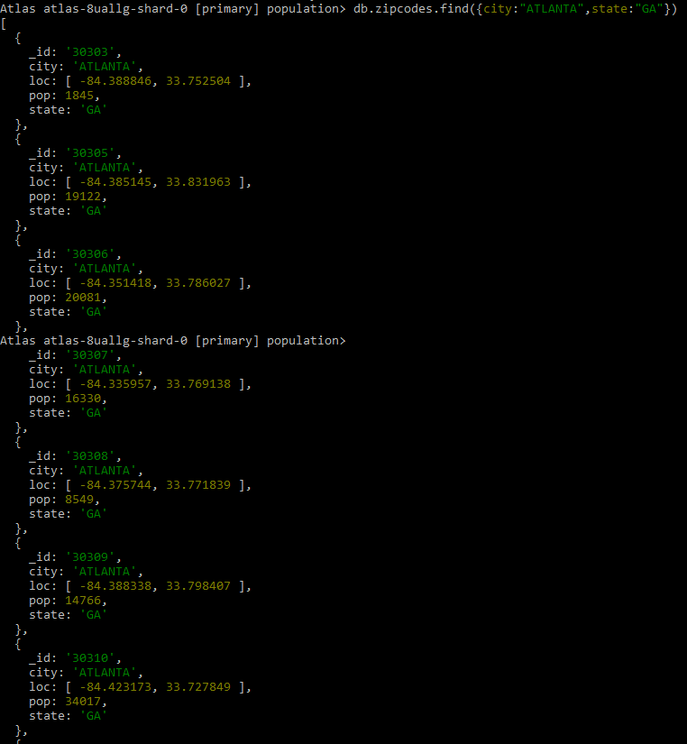

2. Use db.zipcodes.aggregate with $match to do the same as above.

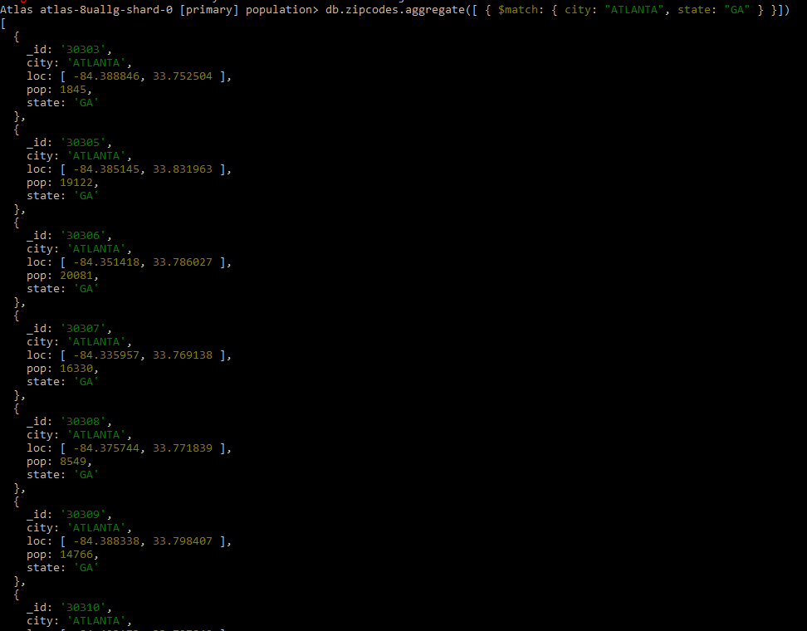

3. Use $group to count the number of zip codes in Atlanta.

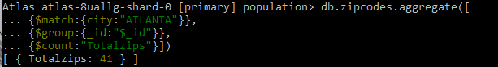



4. Use $group to find the total population in Atlanta.

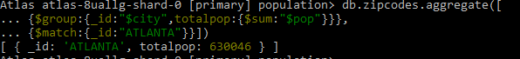

**Populations By State**

1. Use aggregate to calculate the total population for each state

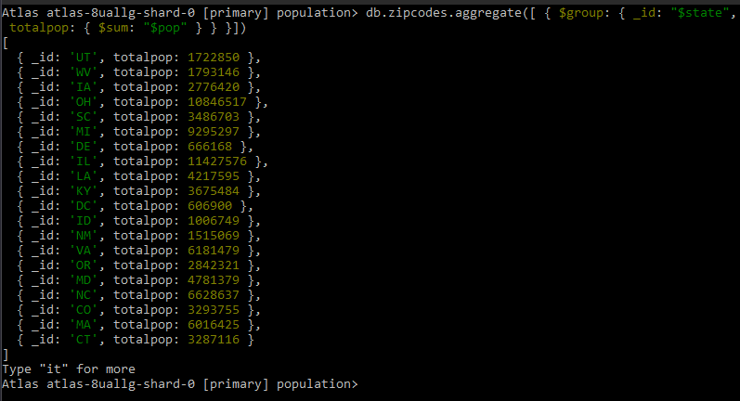

2. Sort the results by population, highest first

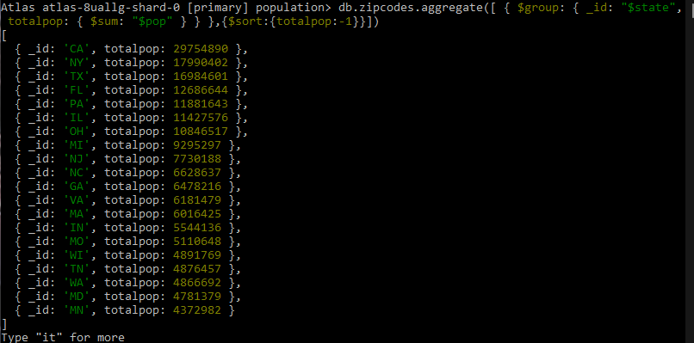

3. Limit the results to just the first 3 results. What are the top 3 states in population?

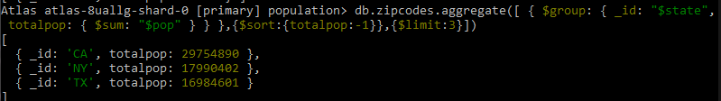

**Populations by City**

1. Use aggregate to calculate the total population for each city (you have to use city/state combination). You can use a combination for the _id of the $group: { city: '$city', state: '$state' }

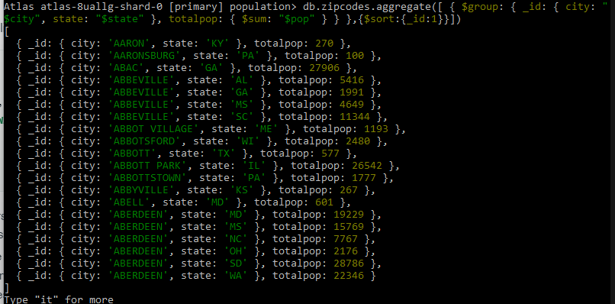

2. Sort the results by population, highest first

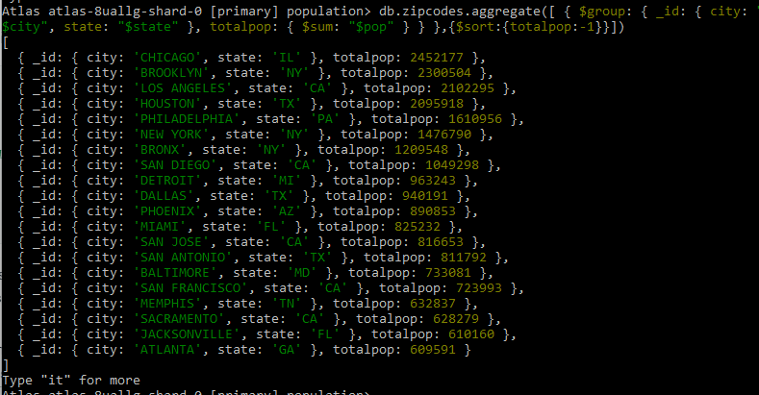

3. Limit the results to just the first 3 results. What are the top 3 cities in population?

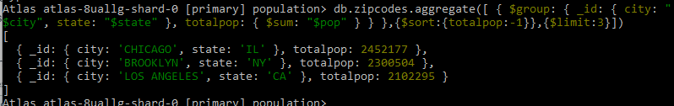

4. What are the top 3 cities in population in Texas?

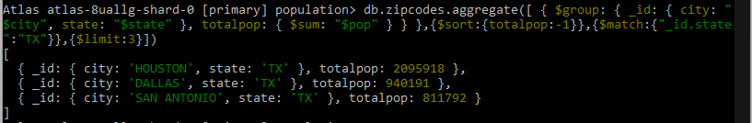

**Bonus**

1. Write a query to get the average city population for each state.

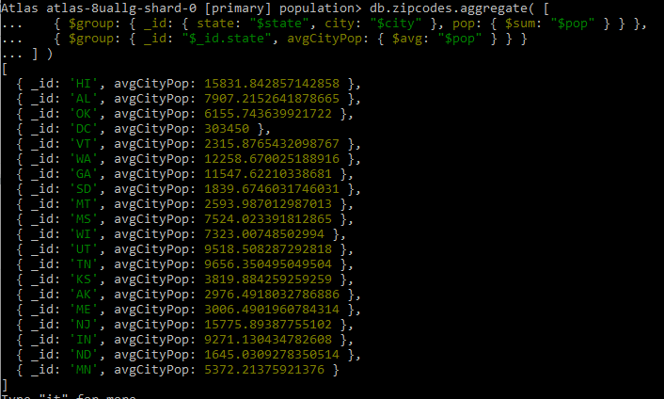

2. What are the top 3 states in terms of average city population?

